AHCA/NCAL: AHCA/NCAL Renews Call For Residents, Staff In Long Term Care Facilities To Receive Prioritization For COVID-19 Vaccine Distribution

Facebook/Twitter
Long term care providers and their residents need priority access to a #COVID19 vaccine when it’s available. More from @ahcancal: https://www.ahcancal.org/News-and-Communications/Press-Releases/Pages/AHCANCAL-Renews-Call-For-Residents,-Staff-In-Long-Term-Care-Facilities-To-Receive-Prioritization-For-COVID-19-Vaccine-Distr.aspx
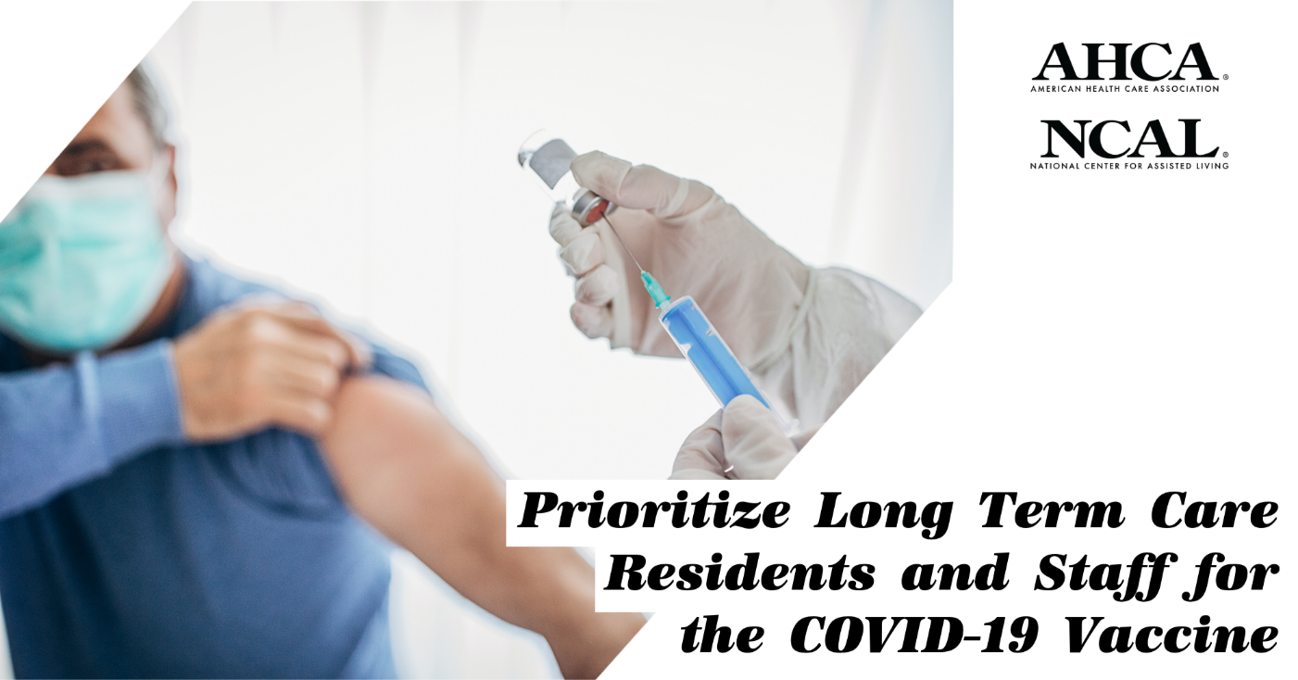

Facebook/Twitter
As #LTCHeroes and long term care residents continue to battle #COVID19, @ahcancal has reiterated their call for vaccine priority. https://www.ahcancal.org/News-and-Communications/Press-Releases/Pages/NCAL-Issues-Statement-Following-HHS-Announcement-On-Funding-For-Assisted-Living-Communities.aspx

LinkedIn: Safely Reopening Nursing Homes And Assisted Living Communities

Facebook/Twitter
Regulators and health officials must work with long term care providers to safely reopen for visitation. More from @ahcancal President and CEO Mark Parkinson: https://www.linkedin.com/pulse/safely-reopening-nursing-homes-assisted-living-mark-parkinson/
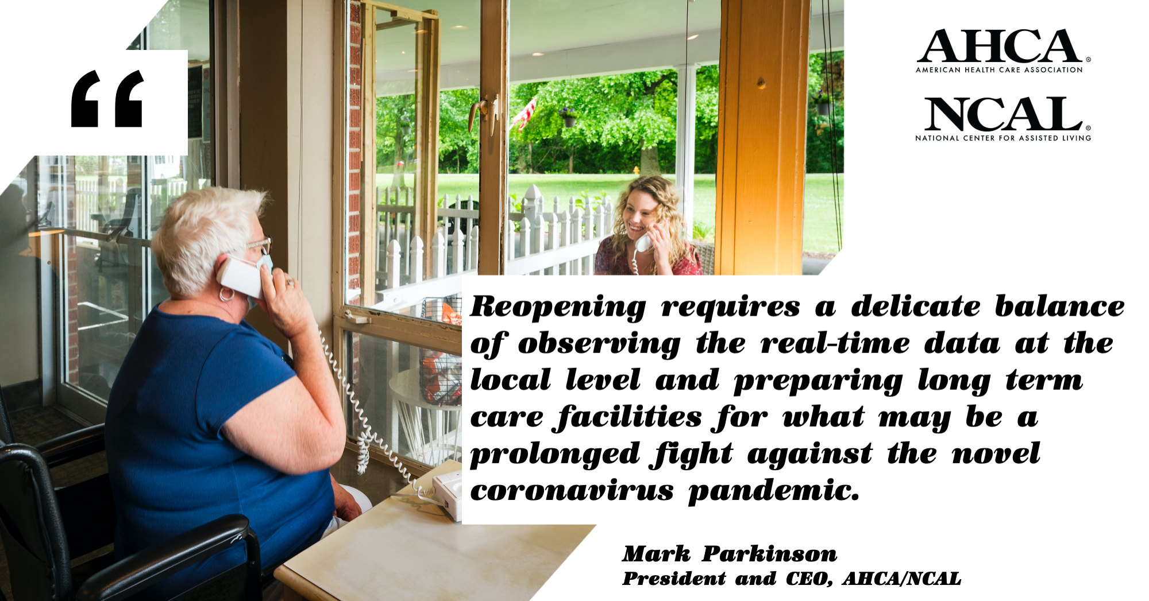

Facebook/Twitter
“We will continue to do whatever it takes to keep our residents and staff safe.” - @ahcancal President and CEO Mark Parkinson on reopening long term care communities.
https://www.linkedin.com/pulse/safely-reopening-nursing-homes-assisted-living-mark-parkinson/

AHCA/NCAL: Share Your Story

Facebook/Twitter
Every day, #LTCHeroes, residents, family members and communities are going the extra mile to beat #COVID19. Share your story now: https://carenotcovid.com/share-your-story/

Facebook/Twitter
In their efforts to showcase the heroic efforts of #LTCHeroes, residents, family members and communities, @ahcancal wants to hear your story. https://carenotcovid.com/share-your-story/

