AHCA/NCAL: Nursing Homes Incurring Significant Costs and Financial Hardship in Response to COVID-19

Facebook/Twitter
9 out of 10 nursing homes say government funding is extremely or very important to helping with COVID-related costs and losses. We must continue to support our #LTCHeroes and the vulnerable seniors they care for. https://www.ahcancal.org/News/news_releases/Documents/Survey-SNF-COVID-Costs.pdf
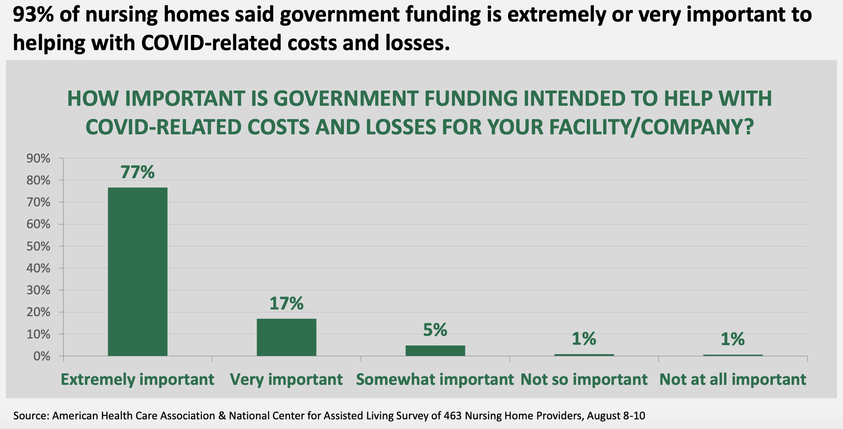

Facebook/Twitter
According to a survey from @ahcancal, nursing homes are facing increased costs due to #COVID19. We must rally around our long term care providers so they can get the resources and funding they need to protect the Greatest Generation.
https://www.ahcancal.org/News/news_releases/Documents/Survey-SNF-COVID-Costs.pdf
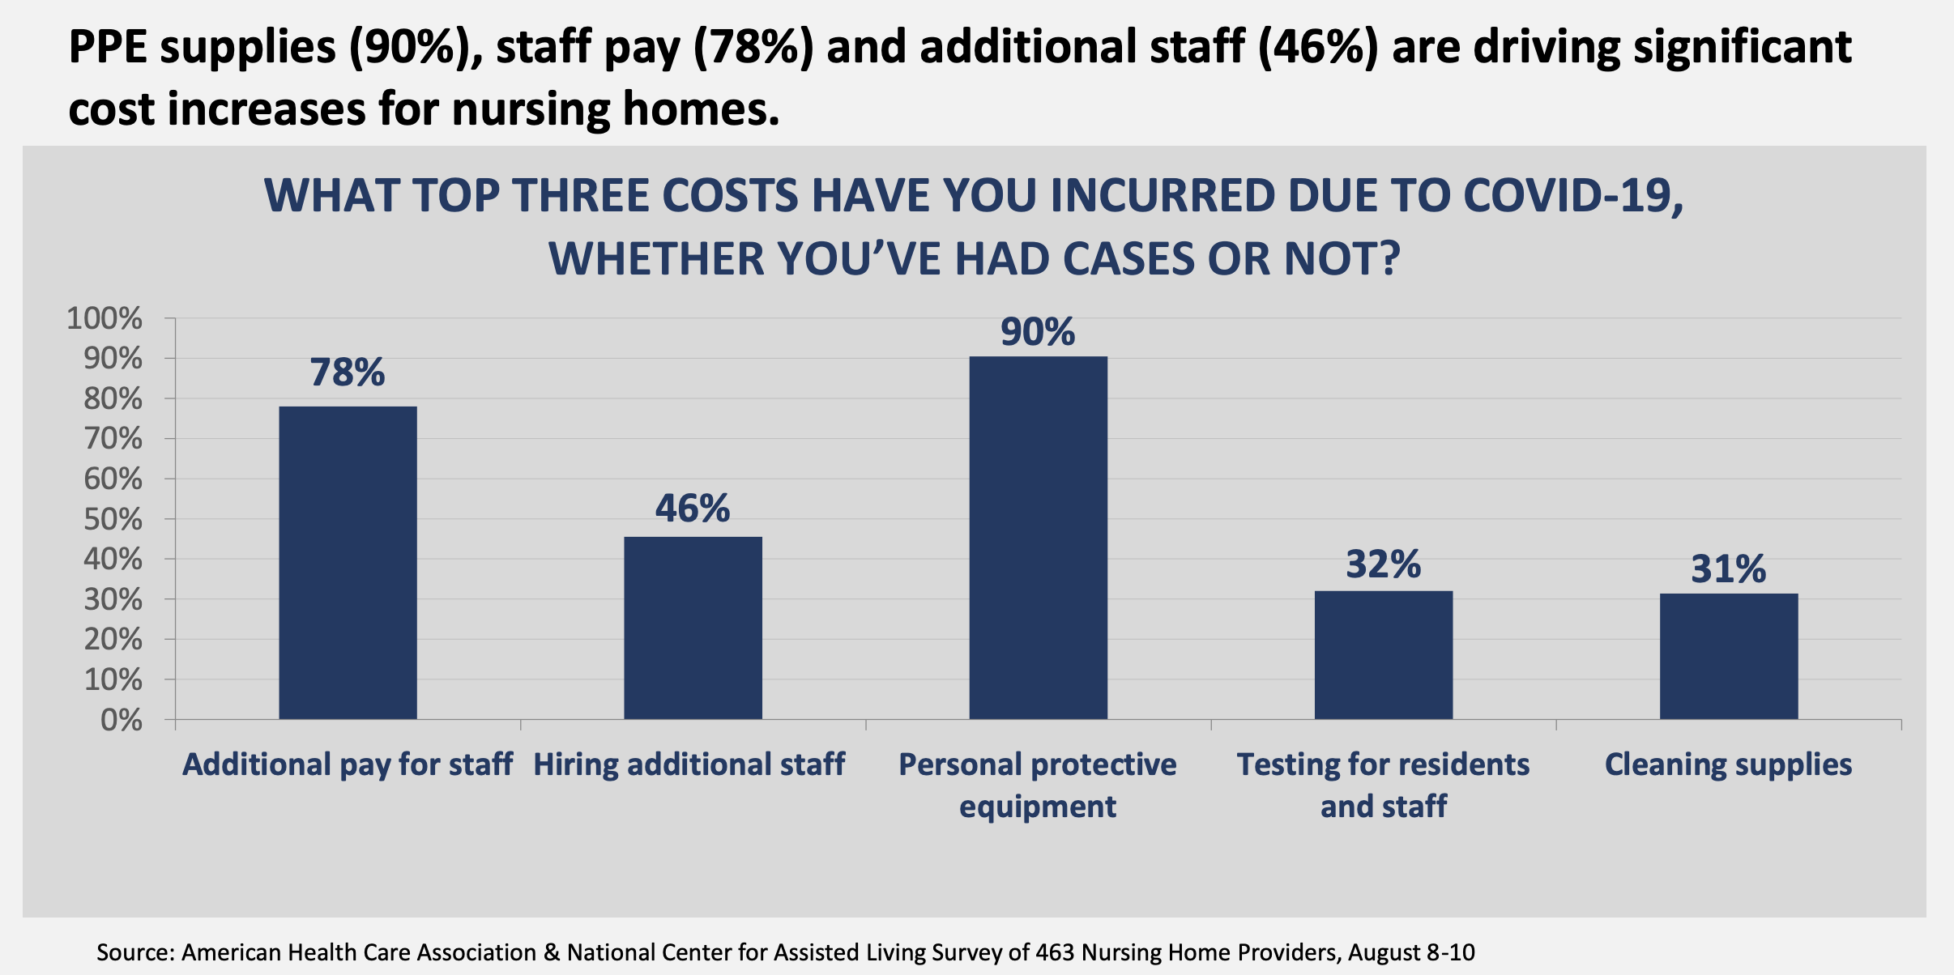

Facebook/Twitter
Long term care providers and #LTCHeroes need and deserve support through the #COVID19 pandemic and beyond.
https://www.ahcancal.org/News/news_releases/Documents/Survey-SNF-COVID-Costs.pdf
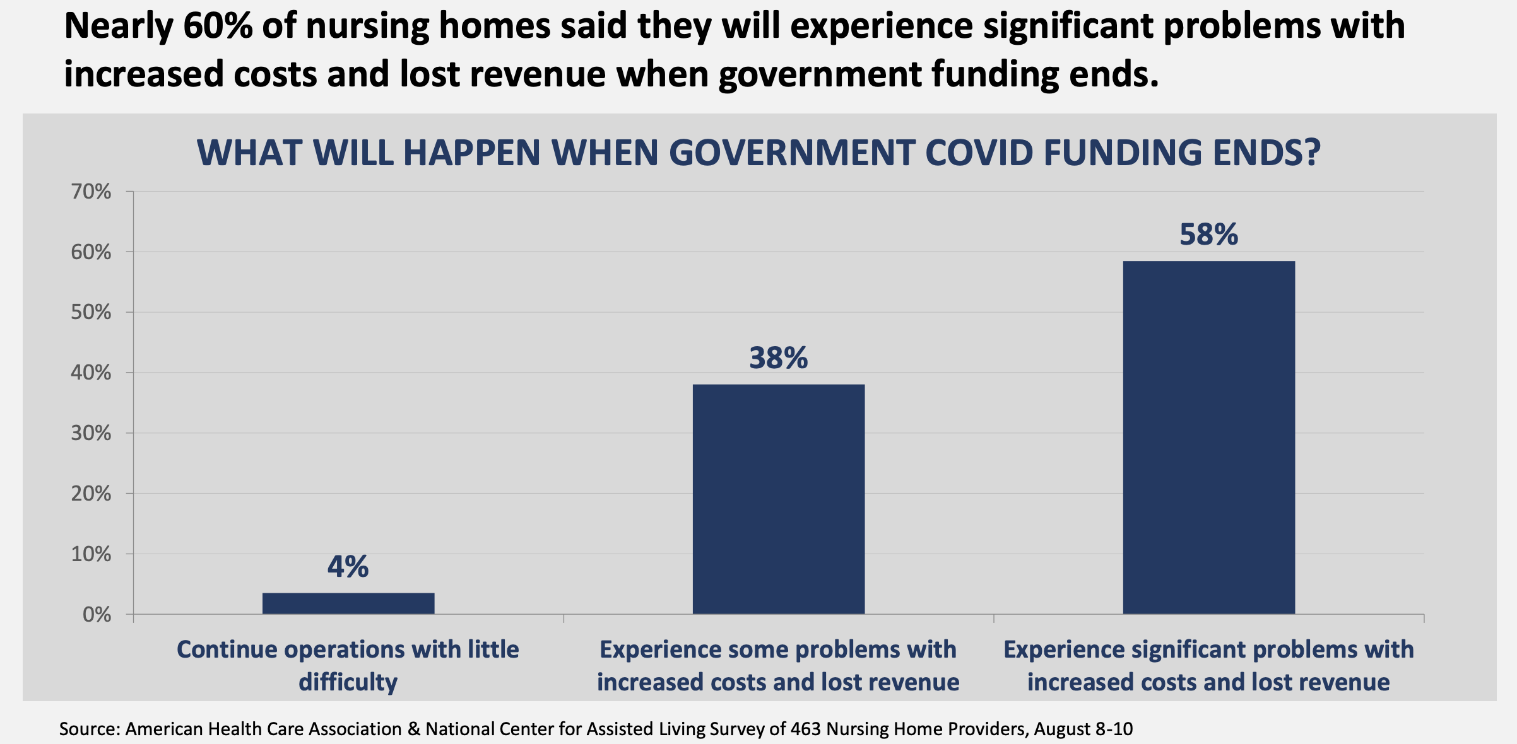

AHCA/NCAL: Survey: Assisted Living Incurring Significant Costs and Financial Hardship in Response to COVID-19

Facebook/Twitter
Assisted living providers haven’t received any direct federal support, but are facing significant costs as they work to protect vulnerable seniors. https://www.ahcancal.org/News/news_releases/Documents/Survey-AL-COVID-Costs.pdf
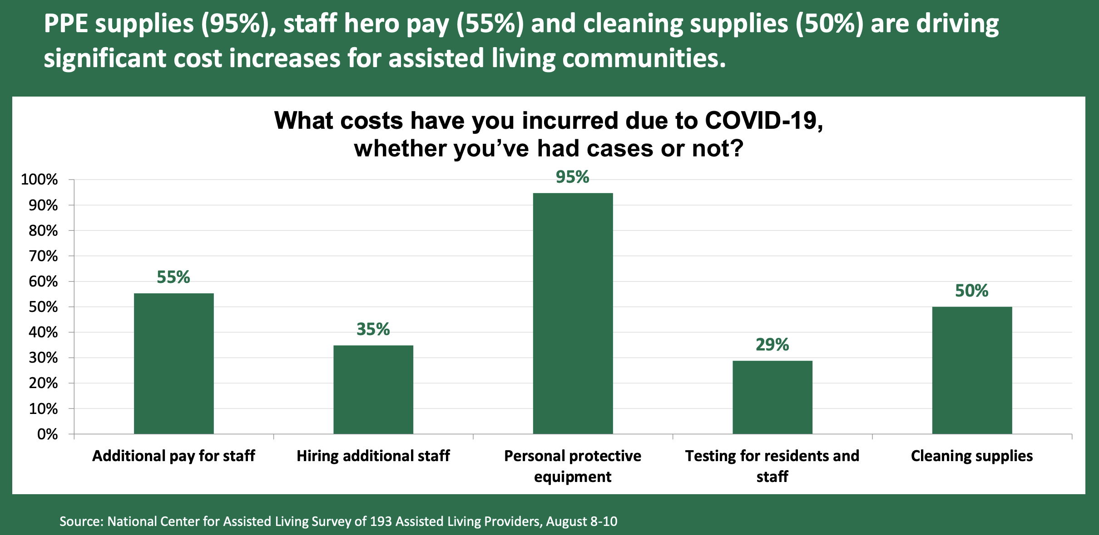

Facebook/Twitter
Without support, more than half of assisted living communities will be unable to sustain operations for another year. https://www.ahcancal.org/News/news_releases/Documents/Survey-AL-COVID-Costs.pdf
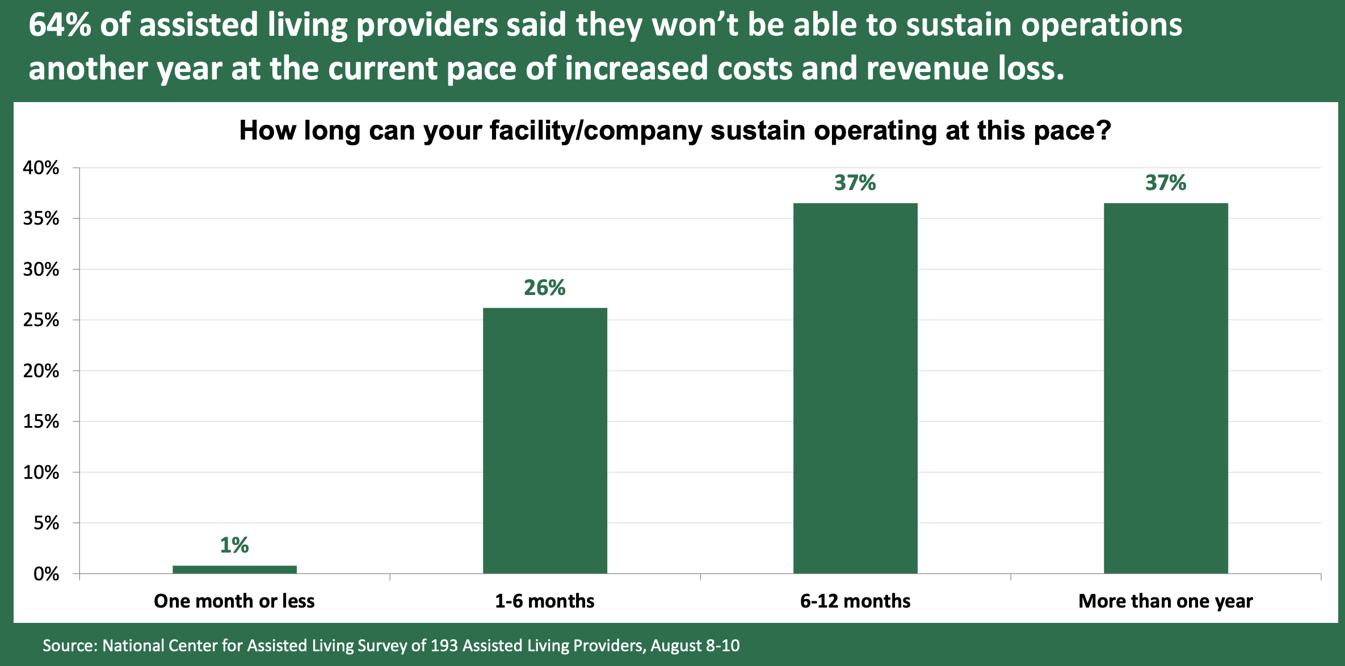

Facebook/Twitter
#LTCHeroes in assisted living communities are fighting to protect vulnerable seniors from #COVID19. We must ensure they have the resources they need to continue the fight. https://www.ahcancal.org/News/news_releases/Documents/Survey-AL-COVID-Costs.pdf
