Stimulus Asks

Facebook/Twitter
As Congress considers the next round of #COVID19 stimulus funding, they must prioritize #LTCHeroes in nursing homes and assisted living communities across the country. https://www.ahcancal.org/News/news_releases/Documents/Stimulus-4-Asks.pdf

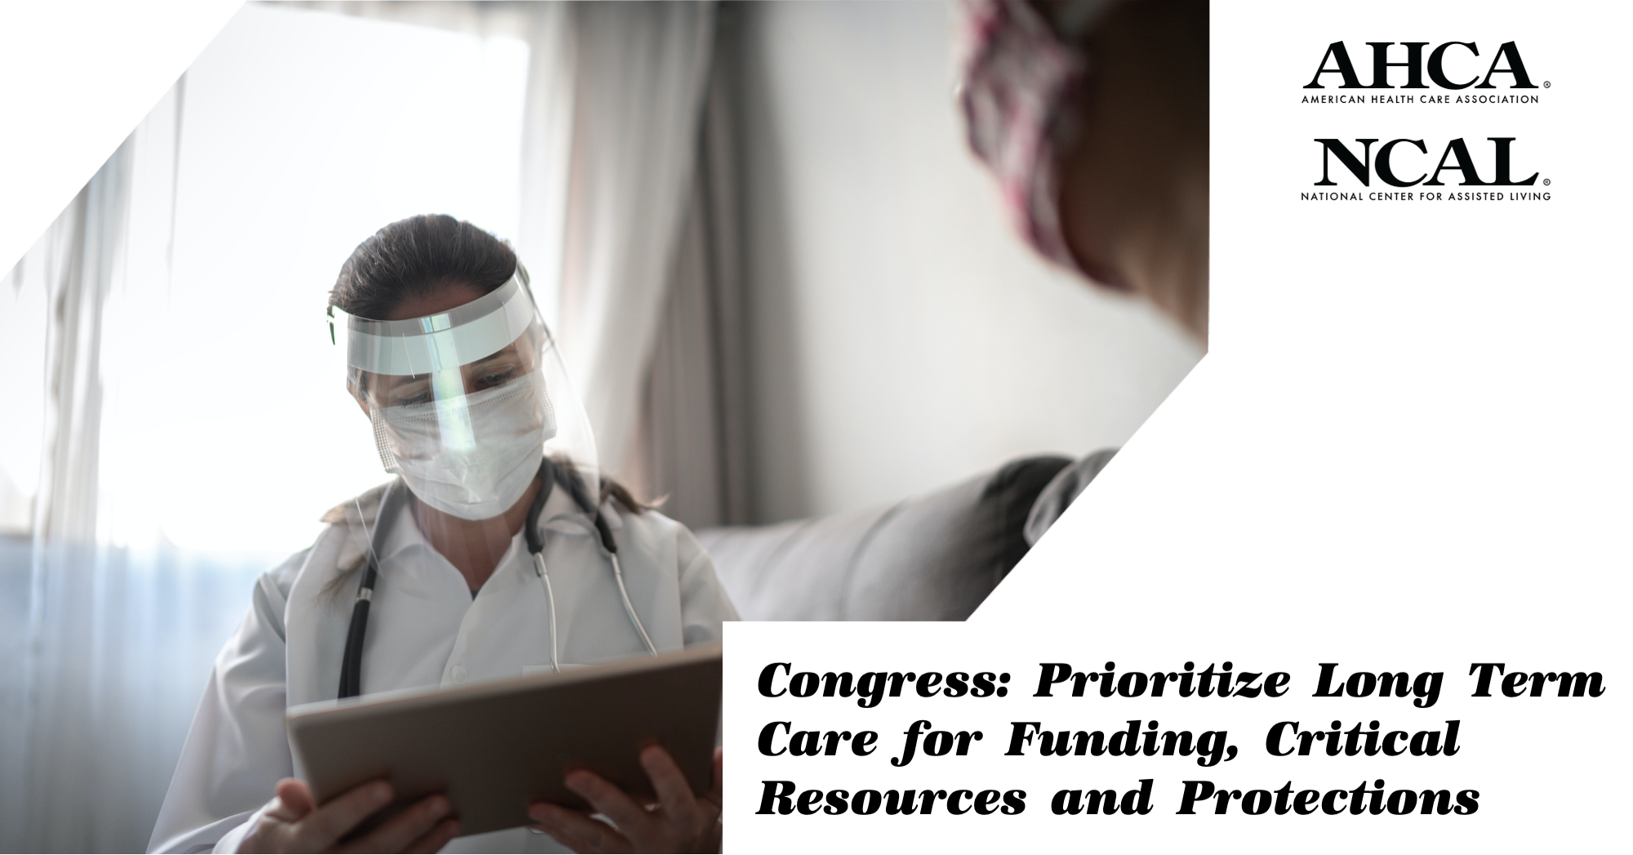

Facebook/Twitter
Long term care providers have undertaken heroic efforts to protect vulnerable seniors from #COVID19. Now, these #LTCHeroes need support from Congress. https://www.ahcancal.org/News/news_releases/Documents/Stimulus-4-Asks.pdf

Facebook/Twitter
Our nation’s seniors deserve our unwavering support. Congress must prioritize those receiving care in nursing homes and assisted living communities. www.saveourseniors.org

AHCA/NCAL: State-By-State Breakdown: COVID-19 Testing Positivity Rates Among The General Population

Facebook/Twitter
As #COVID19 cases spike across the country, many long term care providers are running low on essential #PPE. We must protect our #LTCHeroes and get them the resources they need to safely provide care. https://www.ahcancal.org/News/news_releases/Documents/State-Breakdown-COVID19-Testing-Positivity-Rates-PPE.pdf

Facebook/Twitter
With cases in the community rising coupled with a lack of testing and #PPE, long term care providers’ work to protect vulnerable seniors could be undone. They need our support now! https://www.ahcancal.org/News/news_releases/Documents/State-Breakdown-COVID19-Testing-Positivity-Rates-PPE.pdf

PPE is still hard to come by. As cases rise across the country, public health officials need to direct masks and gowns to nursing homes and assisted living communities. Protect our #LTCheroes! https://www.ahcancal.org/News/news_releases/Documents/State-Breakdown-COVID19-Testing-Positivity-Rates-PPE.pdf

AHCA/NCAL: Financial Crisis of Nursing Home Industry

Facebook/Twitter
Due in part to Medicaid underfunding, more than 500 nursing homes have closed since 2015. Policymakers need to support long term care providers and ensure America’s seniors have access to the care they need. https://www.ahcancal.org/News/news_releases/Documents/Nursing-Homes-Facing-Financial-Crisis.pdf

Facebook/Twitter
Long term care providers have faced chronic Medicaid underfunding for years. Now, the effects are being exacerbated due to #COVID19. We need to ensure our #LTCHeroes and their residents have the funding and resources they need. https://www.ahcancal.org/News/news_releases/Documents/Nursing-Homes-Facing-Financial-Crisis.pdf

