AHCA/NCAL Toolkit Social - 6.11.20

Assisted Living Funding Request

Facebook/Twitter
America’s 42,000 assisted living communities should be a priority for federal funding, #PPE and testing. We’re calling on @HHSgov @SecAzar @FEMA_pete to fund these communities and ensure their safety: https://www.ahcancal.org/News/news_releases/Documents/HHS-Letter-AssistedLiving-6-8-20.pdf #CareNotCOVID
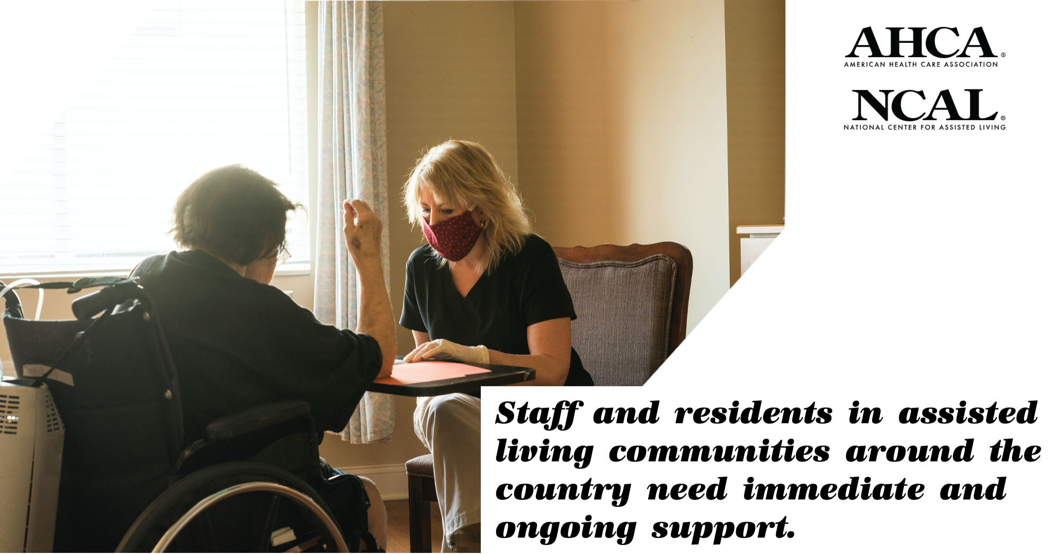

Facebook/Twitter
One million Americans are served by our nation’s assisted living communities. They need federal funding to help test and protect residents and staff from #COVID19. #CareNotCOVID https://www.ahcancal.org/News/news_releases/Documents/HHS-Letter-AssistedLiving-6-8-20.pdf

AHCA/NCAL Reacts to Distribution of Provider Relief Funds for Medicaid Providers

Facebook/Twitter
We applaud the recent decision by @HHSgov to provide specific funding for Medicaid long term care providers and help slow the spread of #COVID19 among this vulnerable population. #CareNotCOVID https://www.ahcancal.org/News/news_releases/Pages/AHCANCAL-Reacts-to-Distribution-of-Provider-Relief-Funds-for-Medicaid-Providers.aspx
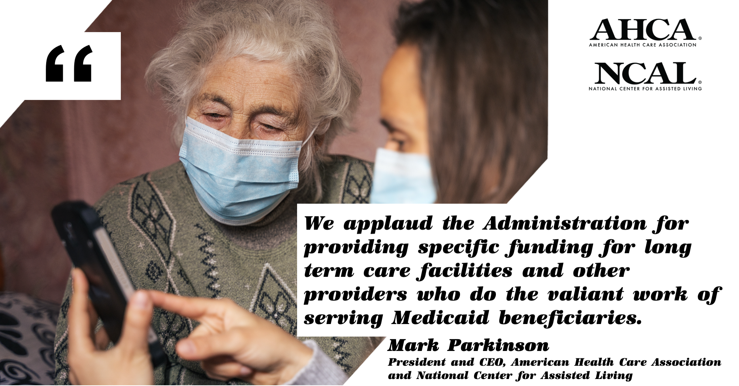

Facebook/Twitter
With new grant distributions from @HHSgov, #LTCHeroes on the front lines will be better equipped to care for long term care residents. #CareNotCOVID https://www.ahcancal.org/News/news_releases/Pages/AHCANCAL-Reacts-to-Distribution-of-Provider-Relief-Funds-for-Medicaid-Providers.aspx

Hilton/AMEX One Million Rooms

Facebook/Twitter
To show their support for our #LTCHeroes, @HiltonHotels and @AmericanExpress are offering rooms at a significant discount through June 30. Members can learn more and take advantage of this offer on our website: https://www.ahcancal.org/about_ahca/ahca_membership/Pages/Hilton-Partnership.aspx
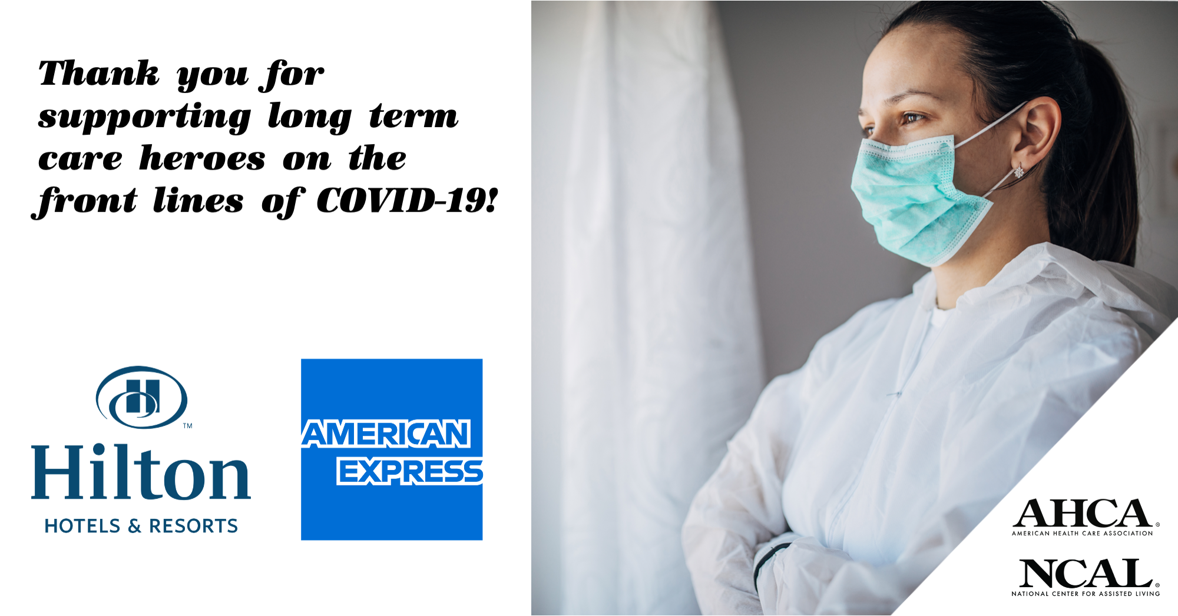

Facebook/Twitter
THANK YOU to @HiltonHotels and @AmericanExpress for donating one million rooms for frontline medical workers and extending discounts for our #LTCHeroes until June 30. https://www.ahcancal.org/about_ahca/ahca_membership/Pages/Hilton-Partnership.aspx

